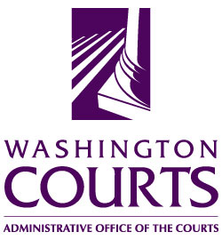

June 19, 2018

TO: Judicial and Legal Communities

FROM: Merrie Gough, Senior Legal Analyst

SUBJECT: 2018 SUMMARY OF CHANGES TO SEXUAL ASSAULT PROTECTION ORDER FORMS

The Washington Pattern Forms Committee approved a recommended change to the mandatory Sexual Assault Protection Order Forms.

A detailed description of the change is in the table below:

No. | Form No. | Title and description of changes.
1. | SA 2.015 | Temporary Sexual Assault Protection Order and Notice of Hearing  On page two, change the paragraph between the check box for Surrender of Weapons and the box for WACIC data entry as follows:  “The respondent may petition the court to reopen the order file a Respondent’s Petition to Reopen Temporary Sexual Assault Protection Order, form SA 6.050, if the respondent did not receive actual prior notice of the hearing and if the respondent alleges that he or she had a meritorious defense to the order or that the order or its remedy is not authorized by chapter 7.90 RCW.”

